I want an app that can perform analysis based on premarket and data between 09 am to 09:15 am and further continue to provide the analysis based on live data post 09:15 am recommended buy/sell FNO items.
Now I'll build a comprehensive F&O trading analysis app with premarket, opening phase (9:00–9:15 AM), and live data analysis powered by Claude AI.

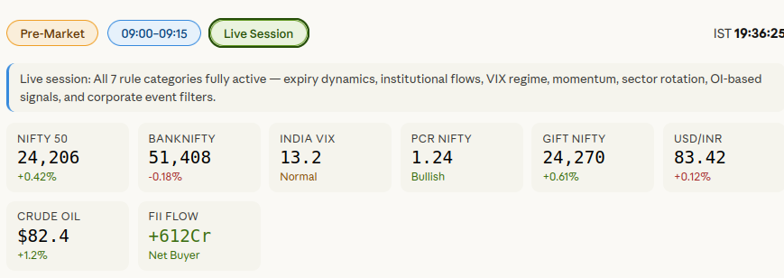

Live session (post 09:15 IST): Real-time tracking of price action, PCR movement, IV crush/expansion, max pain, and momentum to generate actionable F&O buy/sell calls.

